AI / ML CAPSTONE MAJOR PROJECT
CBCT Dental Segmentation
Automated Tooth Segmentation from CBCT Scans using a 2D U-Net

Submitted by | Manvansh Singh
Program | B.Tech, Robotics & AI (Batch 2028)
Institution | Chandigarh Engineering College, CGC Landran
Submitted as part of | Summer ML Training Program 2026
Date | July 2026

Test Dice 0.7479 • Test IoU 0.6948 • 2D U-Net, 7.7M parameters

Table of Contents
01 Title Page1
02 Certificate3
03 Acknowledgement4
04 Abstract5
05 Introduction5
06 Problem Statement5
07 Objectives5
08 Literature Review6
09 Dataset Description6
10 System Requirements7
11 Methodology7
12 Data Cleaning8
13 Feature Engineering8
14 ML Models Used8
15 DL Architecture8
16 Evaluation Metrics9
17 API Development10
18 Deployment Process10
19 Results & Analysis10
20 Screenshots11
21 Challenges Faced14
22 Future Enhancements15
23 Conclusion15
24 References15

CERTIFICATE
This is to certify that Manvansh Singh, a student of B.Tech (Robotics & AI), Batch 2028, at Chandigarh Engineering College, CGC Landran, has successfully completed the AI/ML Capstone Major Project titled “CBCT Dental Segmentation: Automated Tooth Segmentation from CBCT Scans using a 2D U-Net” as part of the Summer ML Training Program 2026, under the supervision of the undersigned.
The work embodies the results of the student’s own investigation, design, and implementation, carried out during the training period, and is hereby approved for submission.

Faculty Mentor: Ms. Shaina Guru
Designation: ____________________________
Signature: ____________________________
Date: ____________________________

ACKNOWLEDGEMENT
I would like to express my sincere gratitude to my faculty mentor, Ms. Shaina Guru, and the Summer ML Training Program team at Chandigarh Engineering College, CGC Landran, for their guidance and support throughout this project.
I am also thankful to my institution for providing the resources and learning environment that made this work possible, and to my peers for their valuable feedback during development.

04 Abstract
Cone-Beam Computed Tomography (CBCT) is widely used in dentistry for diagnosis and treatment planning, but manual segmentation of teeth from CBCT volumes is time-consuming and subject to inter-observer variability. This project presents an automated tooth segmentation pipeline built on a 2D U-Net convolutional neural network, trained on 48 patient CBCT volumes (14,790 axial slices) to produce per-slice binary tooth masks that are stitched back into a 3D volume and refined with post-processing.
The trained model achieves a mean Dice coefficient of 0.7479 and IoU of 0.6948 on a held-out test set. The pipeline is wrapped in a FastAPI backend with a browser-based frontend that accepts a raw CBCT scan, runs inference on GPU, and returns an interactive 3D visualization, a slice-by-slice comparison report, and downloadable prediction files — demonstrating that the model can be deployed as a practically usable diagnostic-assistance tool rather than remaining a notebook-only experiment.

05 Introduction
Cone-Beam Computed Tomography has become a standard imaging modality in modern dentistry, providing detailed 3D views of dental and craniofacial anatomy at lower radiation doses than conventional CT. Accurate segmentation of individual teeth from these volumes underpins several clinical workflows, including orthodontic treatment planning, implant placement, and surgical simulation.
Manual segmentation, however, requires a trained specialist to trace tooth boundaries slice by slice through a volume that can contain hundreds of images — a process that is slow, laborious, and inconsistent between different practitioners. Deep learning — in particular, convolutional neural networks designed for biomedical image segmentation — offers a way to automate this process, learning to identify tooth structures directly from labeled examples rather than relying on hand-crafted rules.
This project implements and deploys such a system: a 2D U-Net trained to segment teeth slice-by-slice from CBCT scans, wrapped in a complete web application so the model can be exercised end-to-end on a new, unseen scan.

06 Problem Statement
Given a raw CBCT scan of a patient’s dental arch, manually identifying and outlining tooth structures across every 2D slice of the 3D volume is time-intensive and dependent on the expertise of the clinician performing the segmentation. There is a need for an automated system that can take a raw CBCT volume as input and produce an accurate, consistent tooth segmentation without manual intervention, while remaining fast enough for practical use and simple enough to be operated through a straightforward interface.

07 Objectives
- Build a complete, reproducible pipeline for preprocessing raw CBCT NIfTI volumes into a form suitable for supervised deep learning.
- Design and train a convolutional neural network capable of accurately segmenting teeth from individual CBCT slices.
- Evaluate the trained model using standard medical image segmentation metrics (Dice coefficient, IoU) on a held-out test set.
- Post-process raw model predictions to remove spurious noise and produce clean, usable 3D segmentation masks.
- Wrap the trained model in a REST API capable of accepting a new scan and returning a segmentation in near real time.
- Build a browser-based frontend that lets a user upload a scan, monitor live processing progress, and inspect the 3D result interactively.
- Package the trained model, evaluation results, and application into a demonstrable, submission-ready deliverable.

08 Literature Review
Early approaches to medical image segmentation relied on classical image-processing techniques such as intensity thresholding, region growing, and watershed transforms. These methods are fast and interpretable but struggle with the variable intensity, noise, and blurred boundaries characteristic of CBCT scans, particularly where adjacent teeth are in close contact.
The introduction of the U-Net architecture by Ronneberger, Fischer, and Brox (2015) established an encoder–decoder convolutional network with skip connections as a strong baseline for biomedical image segmentation, allowing the network to combine coarse contextual information with fine spatial detail. U-Net and its variants have since become a standard choice for a wide range of medical segmentation tasks, including dental imaging, due to their strong performance even with comparatively small labeled datasets.
For this project, a 2D U-Net applied slice-by-slice was chosen over a full 3D convolutional network primarily due to GPU memory constraints (6GB VRAM), which make training a 3D architecture on full-resolution volumes impractical without significant patch-based engineering. This trade-off, and its implications for segmentation consistency across slices, is discussed further in the Challenges and Future Enhancements sections.

09 Dataset Description
The dataset consists of CBCT scans from 48 patients, provided in NIfTI (.nii) format. Each 3D volume was decomposed into individual axial slices for use as training examples for the 2D segmentation model.
Property | Value
Total patients | 48
Total training slices | 14,790
File format | NIfTI (.nii)
Slice resolution | 400 × 400 pixels, single-channel grayscale
Label type | Binary mask (0 = background, 1 = tooth)
Split strategy | Deterministic patient-level split (seed = 42), 8 patients held out for testing
Splitting was performed at the patient level rather than the slice level, ensuring that no slices from a test patient appear in the training set — this avoids information leakage and gives a realistic estimate of performance on genuinely unseen patients.

10 System Requirements

Hardware
GPU | NVIDIA RTX 4050, 6GB VRAM
Training / Inference | CUDA-accelerated (PyTorch)

Software
Language | Python 3.11
Deep Learning | PyTorch 2.5.1 (CUDA build)
Imaging / Preprocessing | nibabel, scipy, scikit-image, NumPy
Backend API | FastAPI, Uvicorn
Visualization | Plotly, Matplotlib
Frontend | HTML, CSS, JavaScript (vanilla)

11 Methodology
The project follows an end-to-end pipeline from raw scan to deployed prediction, consisting of the following stages:
- Data preprocessing — loading raw NIfTI volumes, intensity normalization, and slice extraction.
- Model training — supervised training of a 2D U-Net on labeled slices using a segmentation loss function.
- Evaluation — measuring Dice coefficient and IoU on a held-out patient test set.
- Post-processing — removing small noise components and filling holes in predicted masks.
- API wrapping — exposing the trained model through a FastAPI backend for inference on new scans.
- Frontend integration — building a browser interface for upload, live progress monitoring, and result inspection.
Each stage was validated independently before integration — the model was first evaluated purely offline against ground-truth masks, and only wrapped in the API once its standalone performance was confirmed.

12 Data Cleaning
- Raw CBCT intensities were normalized by dividing each volume by its own maximum value, mapping intensities to a consistent [0, 1] range before being passed to the network.
- Volumes were processed and cached one at a time during data loading to keep memory usage manageable given the large size of individual CBCT files (~278MB each).
- Slices were extracted along the axial plane and treated as independent 2D training examples for the segmentation network.
- The same normalization procedure implemented for training was replicated exactly at inference time, since even small mismatches between training-time and inference-time preprocessing can significantly degrade prediction quality.

13 Feature Engineering
As a deep learning approach, this project relies on learned rather than hand-crafted features: the convolutional layers of the U-Net automatically learn to detect relevant edges, textures, and intensity patterns associated with tooth structures directly from the training data, rather than requiring manually engineered filters.
The main representation decision made explicitly was framing the problem as 2D slice-wise segmentation — each axial slice is treated as an independent single-channel image — rather than processing the full 3D volume at once. This choice was driven by the 6GB VRAM constraint of the available GPU, discussed further in the DL Architecture and Challenges sections.

14 ML Models Used
Classical approaches such as intensity thresholding and watershed segmentation were considered during the design phase but were found inadequate for CBCT data, where tooth boundaries have low and variable contrast against surrounding bone, and adjacent teeth are frequently in close contact. These limitations motivated the choice of a deep learning approach capable of learning more complex, context-aware decision boundaries directly from labeled data.
The final model used for all reported results is the 2D U-Net described in the following section.

15 DL Architecture
Architecture | 2D U-Net (encoder–decoder with skip connections)
Parameters | 7.7 million
Input | 400 × 400, single-channel grayscale slice
Output | 400 × 400 binary mask (0 = background, 1 = tooth)
Loss function | BCEWithLogitsLoss
Optimizer | Adam
Epochs | 10
Training hardware | NVIDIA RTX 4050 (CUDA)
The U-Net’s encoder path progressively downsamples the input to capture broad spatial context, while the decoder path upsamples back to full resolution. Skip connections between corresponding encoder and decoder layers allow fine-grained spatial detail lost during downsampling to be recovered, which is critical for producing precise tooth boundaries rather than coarse blob-like predictions.

16 Evaluation Metrics
Two standard overlap-based metrics were used to evaluate segmentation quality:
- Dice Coefficient — 2 × |Prediction ∩ Ground Truth| / (|Prediction| + |Ground Truth|). Ranges from 0 (no overlap) to 1 (perfect overlap).
- Intersection over Union (IoU) — |Prediction ∩ Ground Truth| / |Prediction ∪ Ground Truth|. A stricter measure than Dice for the same prediction.

Overall Test Set Results
Mean Dice Coefficient | 0.7479
Mean IoU | 0.6948
Test set size | 8 patients (held out, unseen during training)

Per-Patient Breakdown
To understand how performance varies across individual patients, the model was evaluated separately on each of the 8 test patients:
Patient | Dice Score
a1028 | 0.8864
a1062 | 0.8297
a1049 | 0.8272
a1080 | 0.7396
a1011 | 0.7235
a1024 | 0.7108
a1072 | 0.6485
a1030 | 0.6172
Per-patient Dice ranges from 0.6172 to 0.8864, indicating that segmentation quality is meaningfully influenced by individual scan and anatomical variation, rather than the mean Dice alone telling the full story of model behavior.

17 API Development
The trained model is served through a FastAPI backend exposing the following endpoints:
Endpoint | Purpose
POST /predict | Accepts an uploaded .nii scan, validates it, and starts a background inference job
GET /status/{job_id} | Returns live processing status — current pipeline step and progress percentage
GET /download/nii/{job_id} | Returns the predicted segmentation mask as a downloadable .nii file
GET /download/report/{job_id} | Returns a downloadable slice-comparison report (PNG)
GET /health | Reports backend and model status, used for connectivity checks
Inference is executed in a background thread so the API can respond immediately with a job identifier, while the frontend polls the status endpoint to display genuine, real-time progress — including live per-batch progress during GPU inference — rather than a simulated loading animation.

18 Deployment Process
The application is deployed locally: the FastAPI backend serves both the inference API and the static frontend files from a single process, launched via Uvicorn on 127.0.0.1:8000. This avoids the added complexity of cloud hosting for what is, at this stage, a local demonstration tool, while keeping the architecture cloud-deployment-ready — the same FastAPI application could be containerized and deployed to a platform such as Render or AWS with minimal changes.
On startup, the trained model weights are loaded once into GPU memory and kept resident for the lifetime of the server process, avoiding repeated load overhead on every request. A typical end-to-end scan — from upload through inference to a rendered 3D result — completes in approximately 30–50 seconds on the development hardware.

19 Results & Analysis
The trained model achieved a mean Dice coefficient of 0.7479 and IoU of 0.6948 on the held-out test set. Qualitative inspection of predictions on multiple test scans confirms that the model reliably identifies the general tooth arch structure and produces anatomically plausible segmentations.
Per-patient analysis (see Evaluation Metrics) shows Dice scores ranging from 0.6172 to 0.8864. Higher-scoring scans produce a single, well-connected predicted tooth mass, while lower-scoring scans show more fragmentation — several disconnected clusters rather than one continuous arch. This is consistent with a known limitation of slice-wise 2D segmentation: because each axial slice is predicted independently, the network has no explicit mechanism to enforce consistency between adjacent slices, which can produce gaps in the reconstructed 3D volume even when individual 2D predictions are reasonable. A full walkthrough of the deployed application, including the 3D result view and slice-by-slice comparison report, is shown in the Screenshots section that follows.

20 Screenshots
The following screenshots document a complete run of the deployed application, from the landing page through to the downloadable results, on test scan a1028.nii (575,779 predicted tooth voxels).
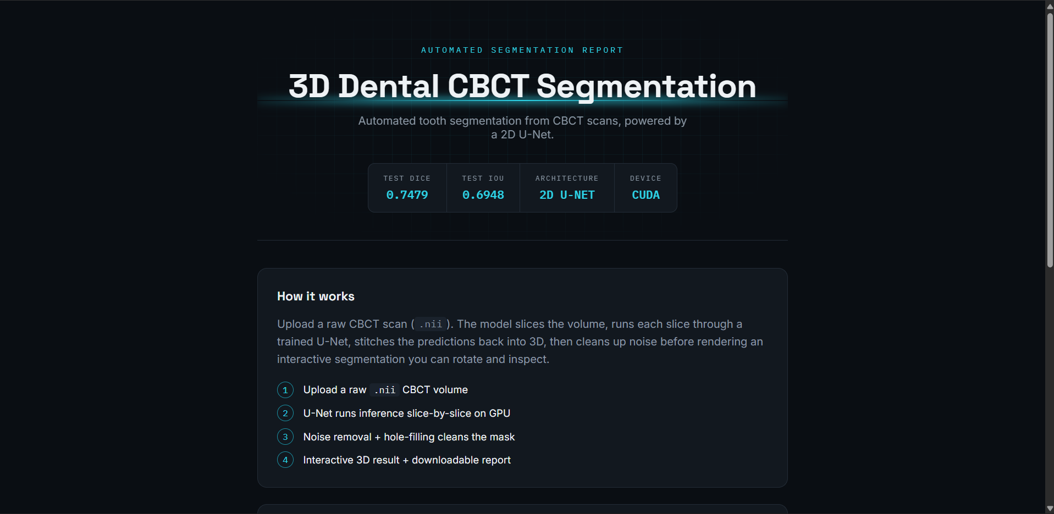
Figure 1: Landing page — project name, tagline, and live model statistics (Test Dice 0.7479, Test IoU 0.6948).
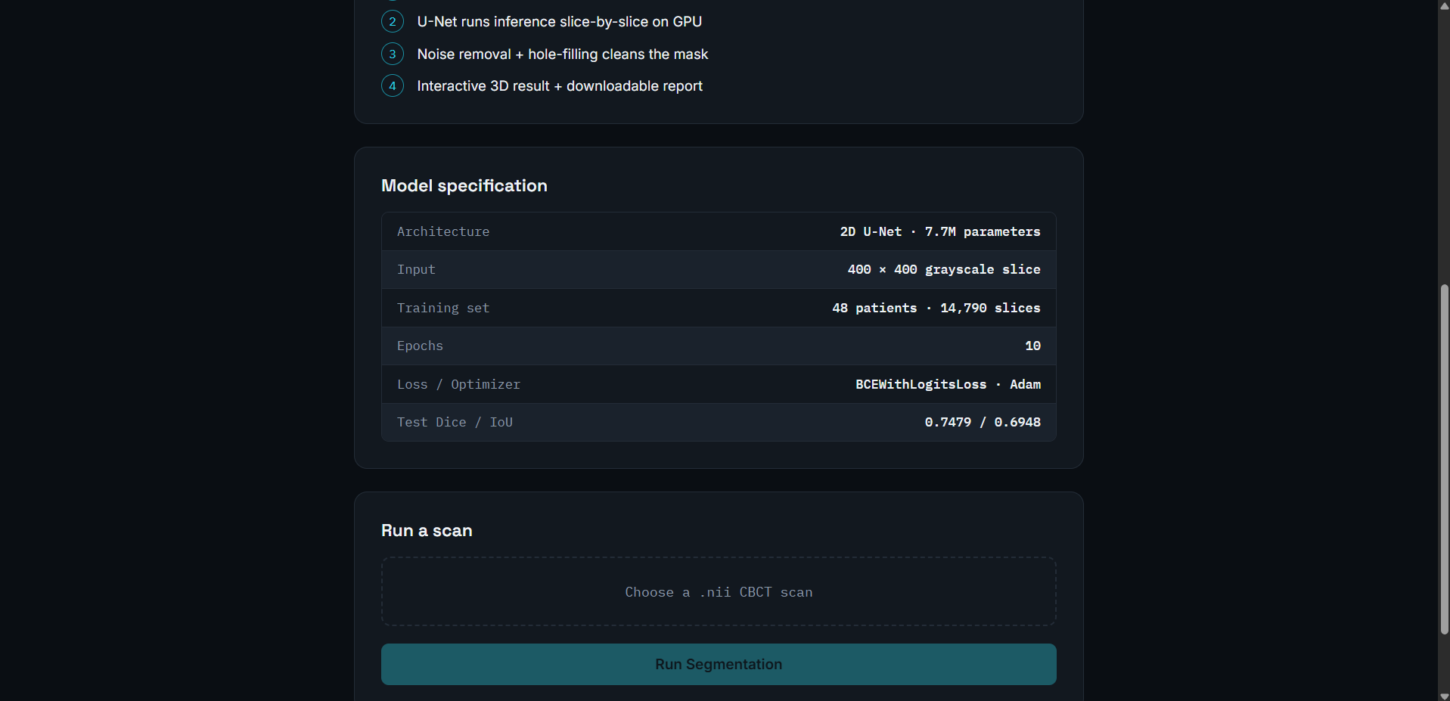
Figure 2: “How it works” overview and full model specification panel.
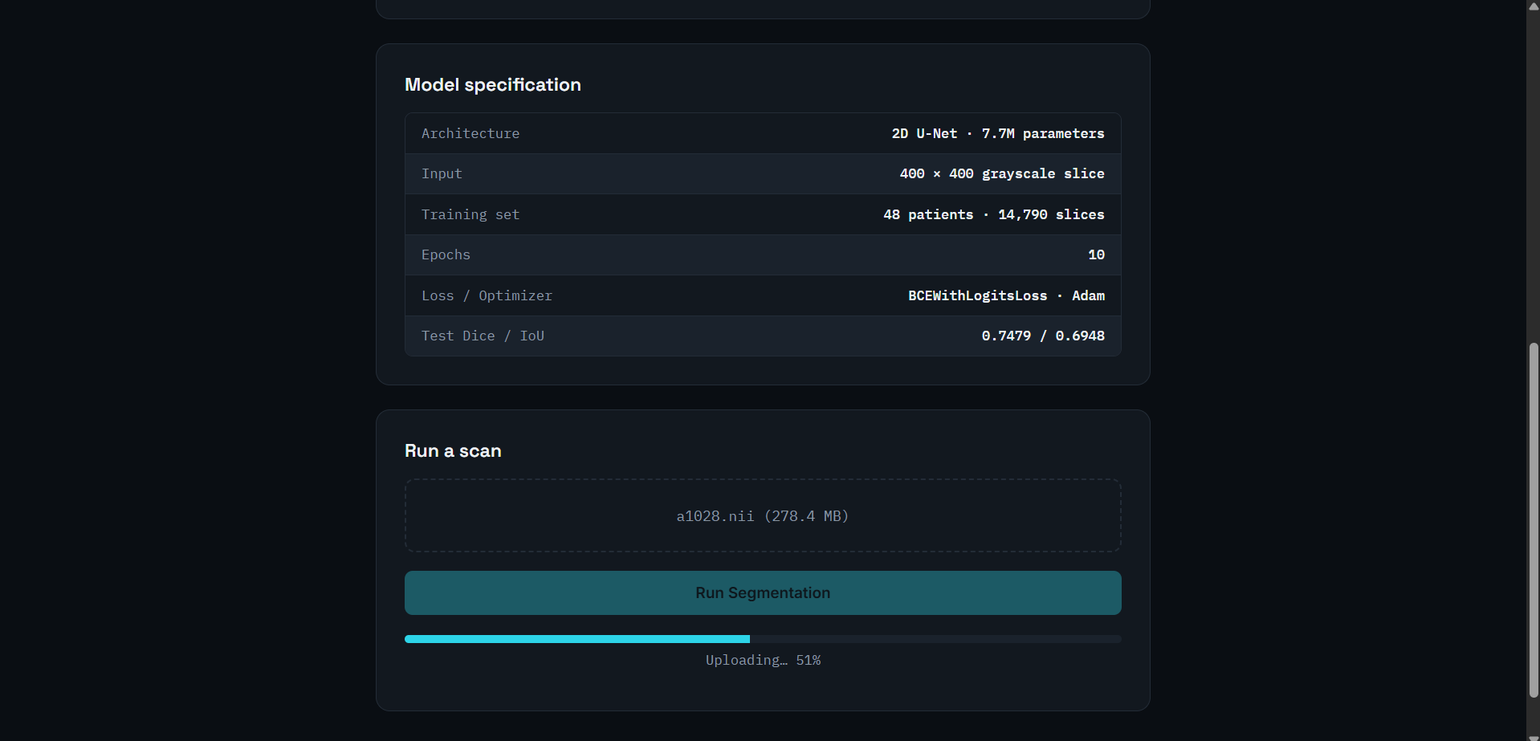
Figure 3: Scan upload in progress — a1028.nii (278.4 MB) being transferred to the backend.
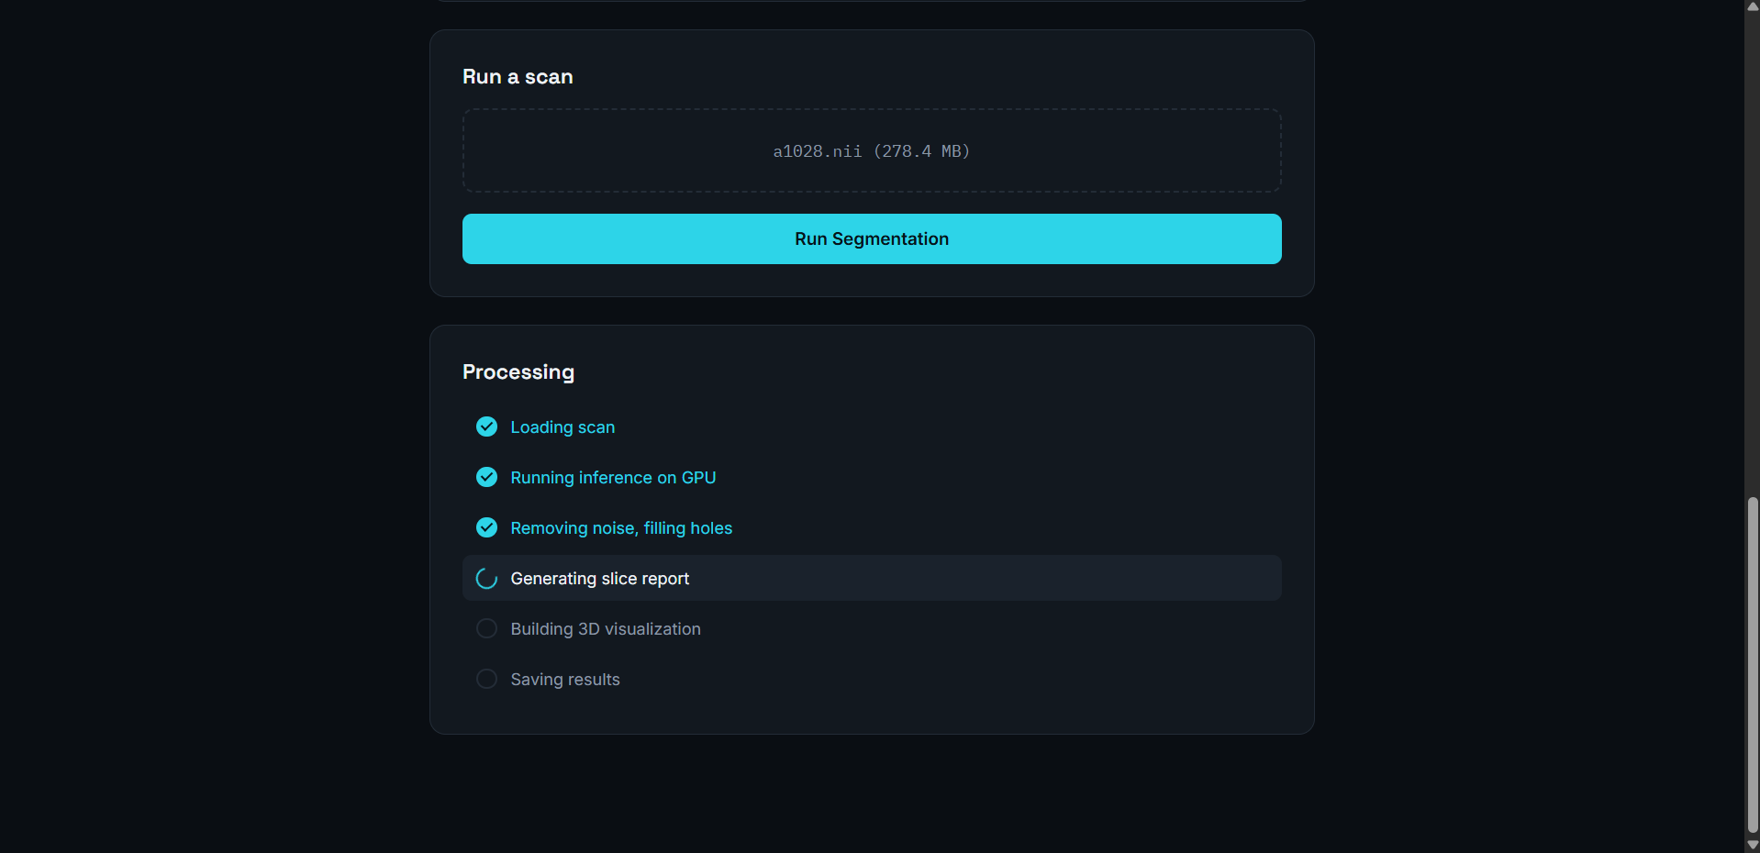
Figure 4: Live processing checklist, showing pipeline stages completing in real time via the /status endpoint.
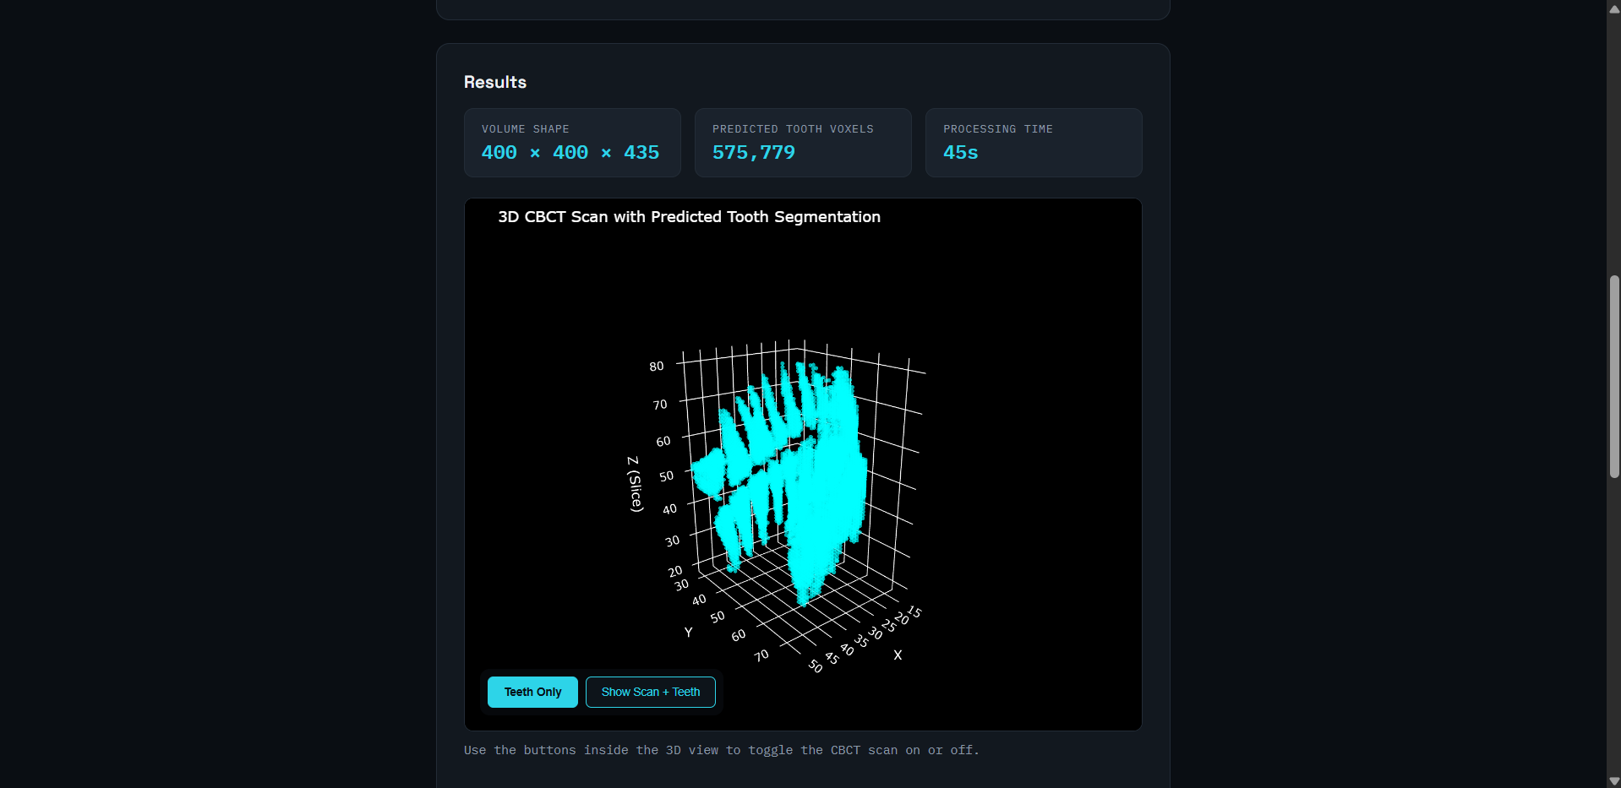
Figure 5: Interactive 3D segmentation result — predicted tooth voxels rendered with rotate/zoom controls.
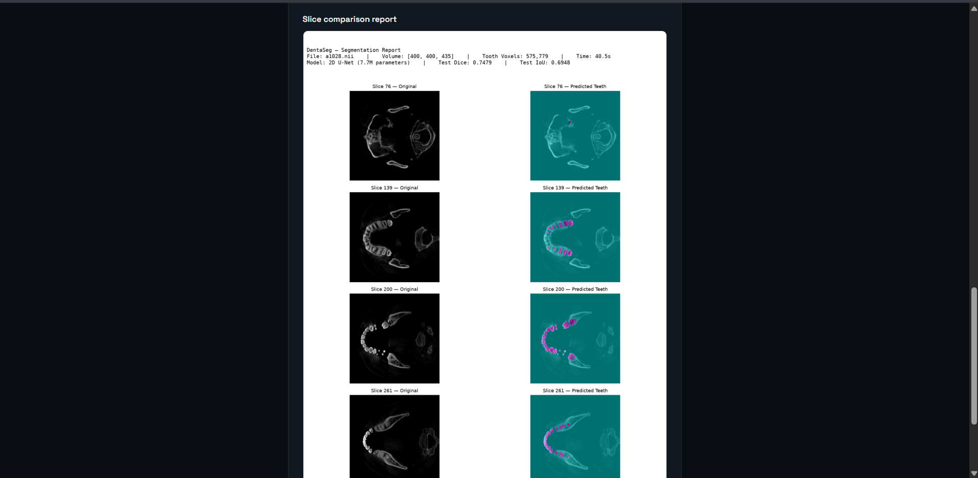
Figure 6: Slice-by-slice comparison report — original CBCT slices alongside predicted tooth masks (magenta) at four depths.
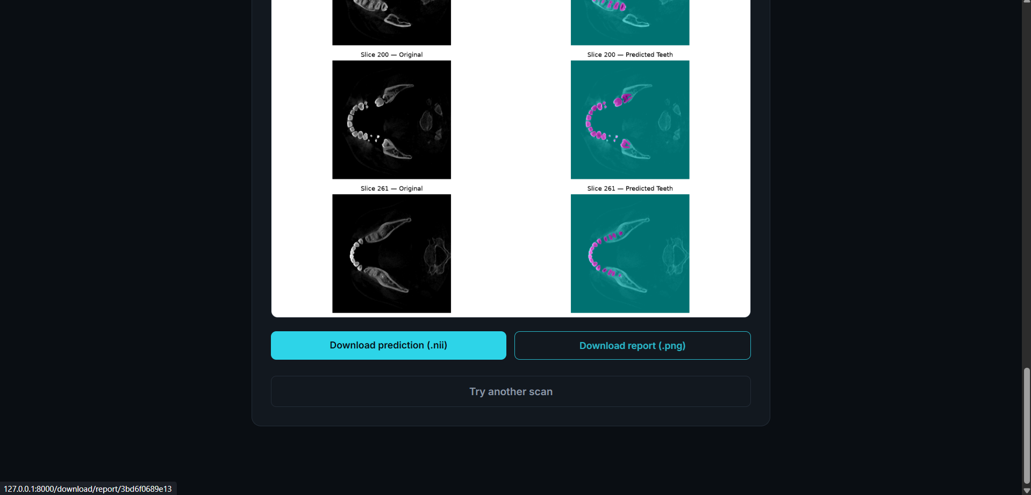
Figure 7: Downloadable outputs — predicted mask (.nii) and comparison report (.png), with an option to run another scan.
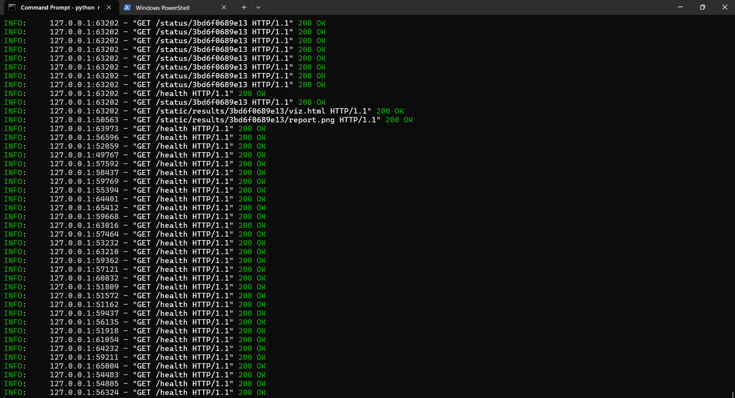
Figure 8: Backend server log confirming live request handling during a session (status polling, health checks, result retrieval).

21 Challenges Faced
- GPU memory constraints (6GB VRAM) made a full 3D U-Net impractical without patch-based training, motivating the 2D slice-wise design and its associated inter-slice consistency trade-off.
- Preprocessing had to be replicated exactly between training and inference — even small mismatches in normalization would silently degrade prediction quality without raising an error.
- Handling large (~278MB) raw scan uploads required a streaming file-save approach and a background job architecture, rather than a single synchronous request, so the interface could report genuine live progress rather than blocking silently for minutes.
- Windows-specific environment issues arose during setup — differences between Command Prompt and PowerShell activation syntax, and drive-switching behavior of the cd command — which required care to resolve correctly.
- Initial styling of the interactive 3D visualization’s control buttons using Plotly’s built-in menu system produced readability issues; this was resolved by replacing it with custom-styled HTML controls with full styling control.

22 Future Enhancements
- Extend to a full 3D U-Net or patch-based 3D convolutional approach to better capture inter-slice spatial context and reduce fragmentation in predictions.
- Introduce a slice-consistency loss term during training to explicitly encourage smoother, more connected predictions across the depth axis without requiring a full 3D architecture.
- Extend training beyond 10 epochs with proper validation-loss monitoring to identify the optimal stopping point and reduce the risk of overfitting.
- Deploy the application to a cloud platform for remote access, building on the existing FastAPI architecture which is already structured to support this with minimal changes.
- Expand evaluation to a larger and more diverse patient test set to obtain a more statistically robust estimate of real-world performance.

23 Conclusion
This project successfully delivers a complete, end-to-end automated tooth segmentation system for CBCT scans. A 2D U-Net trained on 48 patients achieves a mean Dice coefficient of 0.7479 on unseen test data, and the trained model is deployed as a functional web application capable of processing a new scan and returning an interactive, downloadable 3D segmentation result in under a minute. Beyond the segmentation model itself, the project demonstrates the practical engineering required to take a trained model from a research notebook to a usable, demonstrable tool — including API design, real-time progress reporting, and interactive visualization — while identifying clear, well-reasoned directions for future improvement.

24 References
Ronneberger, O., Fischer, P., & Brox, T. (2015). U-Net: Convolutional Networks for Biomedical Image Segmentation. Medical Image Computing and Computer-Assisted Intervention (MICCAI).
PyTorch Documentation — https://pytorch.org/docs
FastAPI Documentation — https://fastapi.tiangolo.com
Plotly Python Graphing Library — https://plotly.com/python
NiBabel Documentation — https://nipy.org/nibabel

